

Data-Driven Optimization of Key Performance Drivers in the Luxury Cruise Industry

OKPUNO SOLOMON CHIWETE

Data Number: (cruise_01 & agent_01)

Student Number: 5702954

Word Count: 2197

Submission Due Date: March 20, 2025

EXECUTIVE SUMMARY

The luxury cruise industry depends on data-driven decisions because they optimize customer retention and operational efficiency as well as marketing effectiveness in its competitive environment. This research adopts data analytic methods to deal with these problems while concentrating on customer complaints and agent performance as well as promotion-related impact. The analysis of 5,000 customer records together with 500 agent profiles (5% sample data used) showed restaurant food quality (204.74) and public space issues (201.3) emerged as the major retention-diminishing factors. Despite an average compensation of 199.95 and marketing expenditure of 165.04, customer satisfaction remained low, highlighting inefficiencies in financial allocation. Strategic workforce planning requires attention because full-time agents demonstrate superior retention performance than part-time and zero-hour agents. Additionally, Strategic workforce planning requires focus on full-time agents since they demonstrate better retention than part-time and zero-hour workers.
To enhance performance, this report recommends performance improvement through the development of tailored service recovery frameworks for significant complaints and agent systematic training for consistent service performance and data-driven marketing reallocation to maximize return likelihood. Decision-making occurs in real time through the use of a performance dashboard that also enables AI-powered analytics and predictive modeling provide future optimization opportunities. Implementing the proposed strategies eliminate wasteful financial spending while establishing lasting market dominance through uniform services in luxury cruise operations.

TABLE OF CONTENT

EXECUTIVE SUMMARY ii
SECTION A 1
INTRODUCTION 1
1.1 Business Context and Problem Statement 1
1.2 Business Problem 1
1.3 Objectives of This Study 2
SECTION B 2
METHODOLODY 2
2.1 Dataset Overview 2
2.2 Data Cleaning and Transformation 4
SECTION C 5
DESCRIPTIVE ANALYTICS AND DATA VISUALIZATION 5
3.1 Descriptive Statistics 5
3.2 Customer Retention and Complaint Analysis 6
3.3 Agent Performance Insights 7
3.4 Marketing and Promotions Effectiveness 8
3.5 Key Performance Indicators (KPIs) Dashboard 9
SECTION D 10
MANAGERIAL RECOMMENDATIONS AND BUSINESS IMPACT 10
4.1 Enhancing Customer Retention Strategies 10
4.2 Optimizing Agent Performance and Training 10
4.3 Improving Marketing and Promotions ROI 11
4.4 Implementing a Data-Driven Decision-Making Culture 11
4.5 Limitations of Analysis 12
SECTION E 12
CONCLUSION 12
REFERENCES 14
APPENDIX 16
SUPPLEMENTARY ANALYSIS AND SUPPORTING INSIGHTS 16

LIST OF FIGURES
Figure 1: Stacked bar chart of Complaint Reasons Impact on Customer Retention 6
Figure 2: Stacked Bar chart of Customer Return Likelihood by Agent Job Type 7
Figure 3: Bar Chart of Impact of Promotions on Customer Retention 8
Figure 4: Bar Chart of Key Performance Indicators 9

LIST OF TABLES
Table 1: Variable Definition and Analytical Relevance Table 2
Table 2: Descriptive Statistics for key Metrics 5

SECTION A

INTRODUCTION

1.1 Business Context and Problem Statement
Organizations in the luxury cruise sector must continuously improve their operations and service quality while retaining customers in their dynamic competitive market. Organizations leverage data-driven methods to boost their performance metrics alongside decision-making capabilities thus securing their market standing and financial stability. Advanced analytics provides organizations with performance data about customer satisfaction and agent and marketing activities to detect service weaknesses and develop specific improvement plans. The industry evolution demands companies to implement advanced data analytics systems which help them fulfill customer requirements while achieving market distinction and sustaining enduring growth (Mucci, 2024; Yeohyun and Kyoung, 2020)

1.2 Business Problem
This report addresses four critical challenges impacting business performance:
- Customer Complaints and Retention: Examining customer complaints together with their impact on retention rates to determine the most common complaints. The assessment of service recovery compensation strategies must be conducted to enhance both customer satisfaction and loyalty (Matthews-El and Bottorff, 2024).
- Agent Performance and Customer Experience: The analysis investigates how agent work experience relates to job type and training programs which affect service delivery results and complaint management efficiency (Wren, 2024)
- Marketing and Promotions ROI: Analyzing the impact of marketing expenditures combined with promotional campaigns determines their effectiveness in acquiring new customers and maintaining them in the long term (Beattie, 2024).
- Performance Tracking and Strategic Decision-Making: Developing a real-time performance dashboard to support data-driven managerial decisions and improve operational transparency (Ziemba, 2025).

1.3 Objectives of This Study
The study aims to:
- Utilize data analytics to identify operational inefficiencies and performance bottlenecks.
- Visualize key business trends to facilitate strategic decision-making.
- Provide evidence-based recommendations to enhance customer satisfaction, agent effectiveness, and marketing efficiency.
This study will use a systematic analytical structure that applies descriptive statistics with visualization methods together with performance metrics to create actionable insights that boost business expansion and operational excellence (Hassan, 2024a; Hassan, 2024b).

SECTION B

METHODOLODY

2.1 Dataset Overview
Table 1: Variable Definition and Analytical Relevance Table
Variable | Definition | Data Type | Business Relevance
Agent ID | Unique identifier assigned to each sales agent. | Numerical | Links agent performance to customer experience.
Job-type | Employment status of the agent (parttime/full-time/zero-hours). | Categorical | Evaluates impact of job stability on retention.
Cruise Score | Customer rating of the cruise experience, measured on a scale of 1 to 10. | Numerical | Key measure of customer satisfaction.
Complaint Reason | Primary reason for a customer complaint (e.g., restaurant food quality, plumbing issues, embarkation, public spaces, shore excursions). | Categorical | Identifies service quality gaps.
Compensation | Financial compensation provided to a customer as a service recovery measure. | Numerical | Measures financial impact of complaints.
Marketing | Marketing expenditure allocated per trip in GBP (£). | Numerical | Evaluates marketing efficiency.
Commission | Commission paid to sales agents for ticket sales in GBP (£). | Numerical | Assesses incentive structure.
Return | Likelihood of a customer repurchasing the cruise (yes/no/notsure). | Categorical | Determines retention rates.
Promotions | Indicates whether a promotional offer was applied to the booking (yes/no). | Categorical | Evaluates impact of promotions on retention.

The research analyzes two datasets consisting of a 5% sample which includes the Cruise Dataset with 10 columns and 5,000 records and the Agent Dataset with 6 columns and 500 records. The Cruise dataset contains customer metrics including complaints, compensation, return likelihood, promotions, marketing expenditure and cruise scores. The agent dataset contains information about agent experience alongside job type and qualifications and training status and demographics. A left join operation on agent_id enabled the integration of both datasets to perform analysis between customer experience and agent performance for service quality assessment and marketing effectiveness evaluation and financial impact determination.

2.2 Data Cleaning and Transformation
Handling Missing Data and Standardization
The analysis required removal of records containing missing values for compensation, marketing expenditure and return likelihood to ensure unbiased results. Standardization of categorical variables included training recoding of "don't know" responses to "unsure", removal of ambiguous job type entries, and undefined gender classifications removal (Chua et al., 2015; Frost, 2024).
Outlier Detection and Removal
The Interquartile Range (IQR) method helped eliminate outliers from cruise scores, compensation, commission, and marketing expenditure before statistical analysis. This method calculated first (Q1) and third quartiles (Q3) to identify values exceeding 1.5 times the IQR which were then removed to maintain analysis integrity. Only valid categorical responses were retained, ensuring consistency across return likelihood and complaint types (Bobbitt, 2021; Han and Hyun, 2018).

Final Data Validation
The analysis excluded irregular undefined complaint reasons ("ri") while keeping only the valid promotional entries ("yes"/"no"). The data cleaning process increased accuracy which improved the quality of analysis on customer satisfaction and agent performance alongside financial efficiency data and insights.
Descriptive Statistics and Data Visualization
The analysis calculated summary statistics for cruise scores and compensation and marketing expenses and commission by using mean and min/max and standard deviation. The analysis utilized histograms to display numerical distributions while bar charts showed categorical data and grouped bar chart presented relationships between complaints and returns and compensation trends. The Performance Dashboard integrated all insights into a real-time dashboard through the grid.arrange() structure, providing a real-time reference for decision-making purposes.
The cleaned dataset together with the dashboard provides data-driven foundation to improve service quality, agent performance and financial strategy.

SECTION C

DESCRIPTIVE ANALYTICS AND DATA VISUALIZATION

3.1 Descriptive Statistics
Table 2: Descriptive Statistics for key Metrics
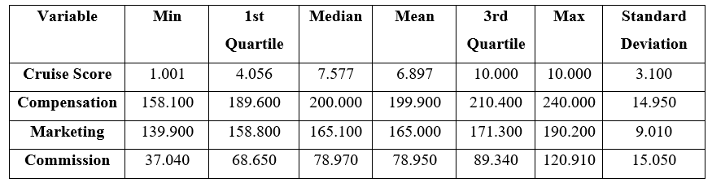
Descriptive statistics reveals insight into key operational metrics which demonstrates differences between customer satisfaction, agent performance and financial payment distribution. From Table 2, the cruise satisfaction scores demonstrate moderate ratings between 1.00 and 10.00 with an average of 6.90. Compensation values span £158.10 to £240.00, averaging £199.90, indicating uneven service recovery payouts. The financial resources allocated for marketing and commission payments show significant variations with mean values at £165.00 and £78.95 (SD: 15.05) respectively. High standard deviations in both compensation (14.95) and commission suggest that financial incentives are not consistently aligned with retention efforts, reinforcing inefficiencies in incentive structures and operational strategy (Execs In The Know, 2022).

3.2 Customer Retention and Complaint Analysis
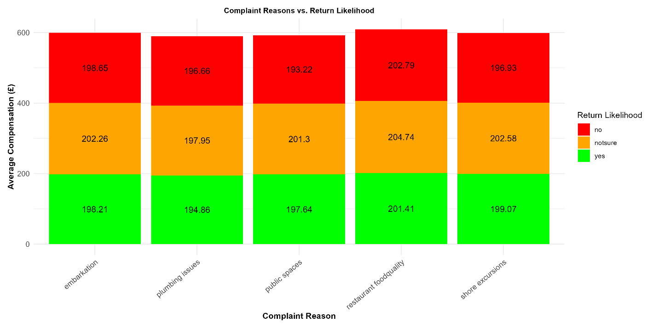
Figure 1: Stacked bar chart of Complaint Reasons Impact on Customer Retention
The average compensation amounts are displayed in Figure 1 according to complaint types and return likelihood categories. Customers who expressed uncertainty about their satisfaction received the highest monetary compensation for restaurant food quality (£204.74) and shore excursions (£202.58) since these issues need substantial financial resolution. The payment amounts given to "no" returners match closely with those given to "yes" returners indicating that compensation levels do not impact customer loyalty. Compensation trends vary primarily by complaint type rather than return likelihood, reinforcing that financial reimbursements show no evidence of being a strategic retention tool because they react to complaints without ensuring lasting customer satisfaction (Chen, 2016).

3.3 Agent Performance Insights
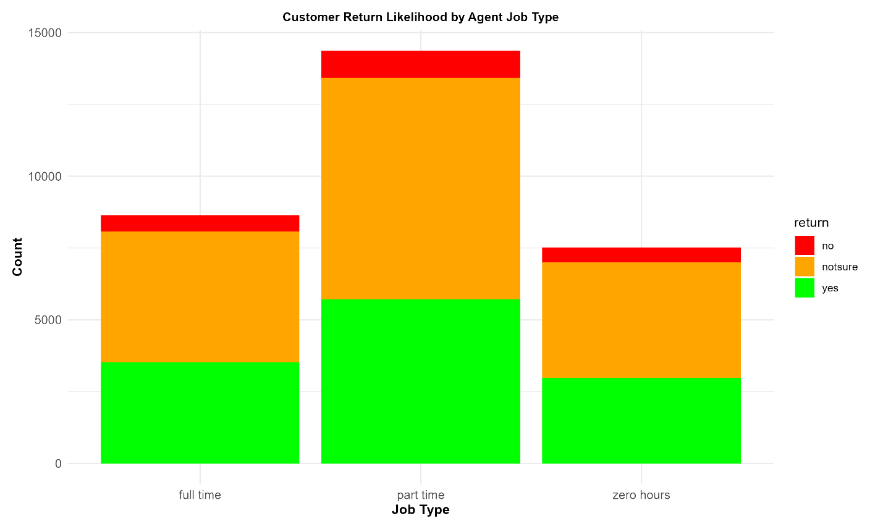
Figure 2: Stacked Bar chart of Customer Return Likelihood by Agent Job Type
Figure 2 shows that agent job type significantly influences customer return behavior. Part-time agents handled the highest number of customers, approaching 15,000, but had the largest proportion of uncertain return likelihood (orange). Full-time agents processed fewer customers yet had a higher proportion of returning customers (green) compared to zero-hour agents. Zero-hour agents handled the smallest volume of customers and exhibited a high share of uncertain (orange) and non-returning customers (red). These findings align with González-Rodríguez et al. (2020), highlighting that job stability and structured employment improve customer service outcomes. Enhancing full-time engagement and providing structured training programs for part-time agents could improve overall customer retention.

3.4 Marketing and Promotions Effectiveness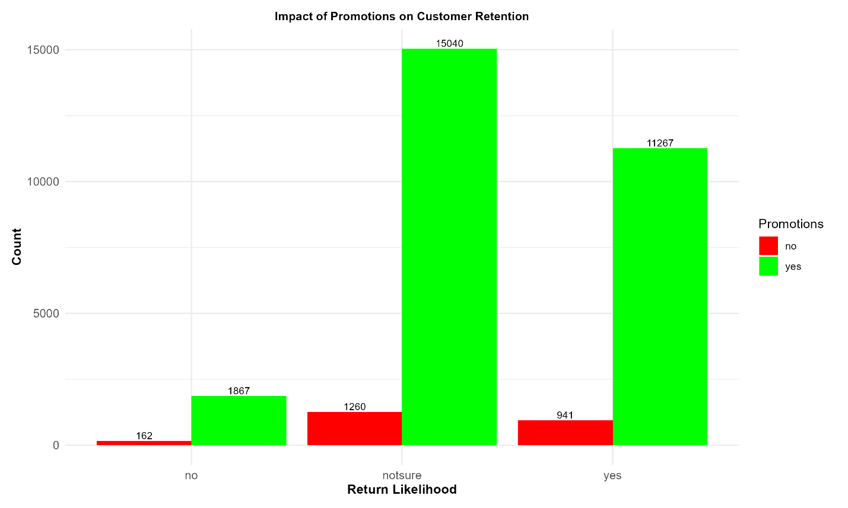
Figure 3: Bar Chart of Impact of Promotions on Customer Retention
Figure 3 demonstrates that promotional activities lead customers to be more likely to return. The data shows that 15,040 promoted customers remained uncertain about returning but 11,267 confirmed their return whereas for non-promoted customers, only 1,260 were uncertain and 941 actually returned. Non-promoted customers who confirmed they would not return numbered just 162 but the promoted customer group totaled 1,867. The data indicates that promotions help retain customers yet the numerous uncertain responses from promoted customers demonstrates the need for marketing improvement to effectively convert reluctant customers into loyal buyers (Calveras, 2015).

3.5 Key Performance Indicators (KPIs) Dashboard
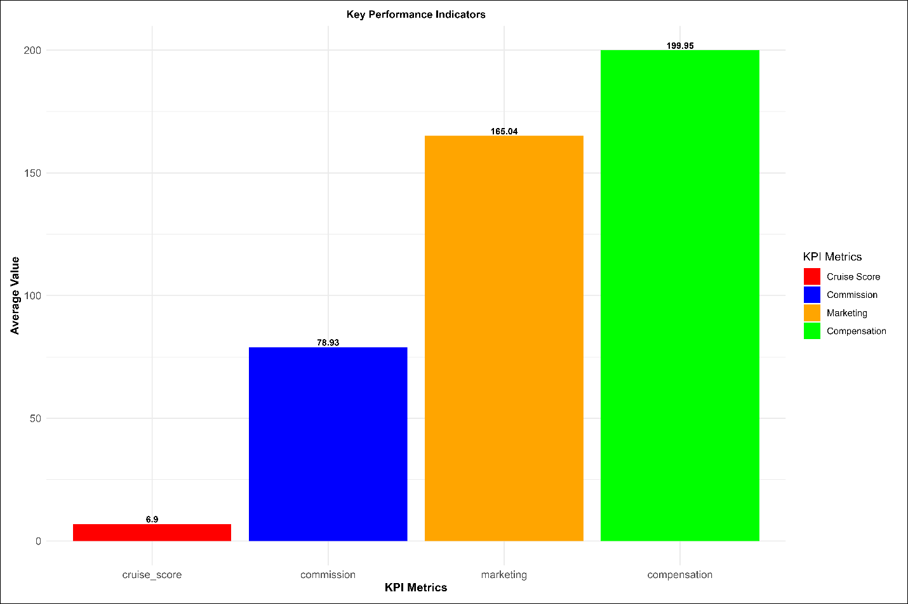
Figure 4: Bar Chart of Key Performance Indicators
Figure 4 shows key business metrics with notable performance differences between them. The average compensation has the highest value reaching 199.95 which indicates significant financial compensation amounts. The data shows marketing expenditure takes the second position at 165.04 which demonstrates substantial promotional budget allocation. Commission payouts, at 78.93, suggest structured agent incentives. In contrast, the cruise score stands at 6.9, considerably lower than financial metrics, implying a disparity between spending and customer satisfaction outcomes The data indicates that increased compensation spending along with marketing expenses and commission payments fails to generate better customer experience (Execs In The Know, 2022).

SECTION D

MANAGERIAL RECOMMENDATIONS AND BUSINESS IMPACT

The analytical assessment identifies essential aspects for improvement in customer retention and agent performance together with marketing productivity and data-driven decision making. Implementing targeted strategies in these areas can enhance operational efficiency and long-term business sustainability.

4.1 Enhancing Customer Retention Strategies
The data in Figure 1 shows that customer complaints together with compensation payments directly affect customer retention (Figure 1). The high compensation paid for restaurant food quality services at £204.74 and shore excursions at £202.58 indicates service recovery needs improvement. The payment amounts for both returning and non-returning customers remain identical which demonstrates that compensation fails to generate customer loyalty. A specific complaint resolution system needs implementation to reduce money loss while boosting customer retention (Chen, 2016).
Actionable Steps
- The organization should enhance service processes to stop high-risk complaints from occurring.
- Predictive analytics should be used to enhance compensation policies.
- The organization should establish real-time complaint tracking systems to enable proactive intervention measures.

Long-Term Impact
The improvement of service quality leads to lower compensation expenses which results in retention based on superior service quality rather than financial rewards.

4.2 Optimizing Agent Performance and Training
The data in Figure 2 shows full-time agents succeed best at retaining customers although part-time and zero-hour agents face difficulties maintaining consistency. Job type does not affect Cruise scores which stay at ~7.5 yet service quality differs because training methods are not standardized. The conversion of successful part-time agents into full-time positions leads to improved workforce stability.
Actionable Steps
- The organization should enhance its training programs that address complaint resolution.
- Introduce performance-based incentives for improved retention.
- Transition top part-time agents into full-time roles.
Long-Term Impact
Higher retention rates and better service quality and consistency, result from having a skilled and stable workforce.

4.3 Improving Marketing and Promotions ROI
The promotional efforts brought back 11,267 customers yet 15,040 customers remained undecided (Figure 3). This signals inefficient promotional targeting. The marketing budget needs strategic reallocation because different agent experience levels receive varying budget amounts.
Actionable Steps
- Target high-Lifetime Value (LTV) customers instead of broad promotions.
- The marketing budget should be allocated to customer segments which demonstrate the highest conversion rates.
- The system needs real-time tracking capabilities to enable reactive adjustments of marketing campaigns.

Long-Term Impact
Through data-driven marketing companies improve their ROI performance and customer retention rates so they can decrease heavy discount strategies.

4.4 Implementing a Data-Driven Decision-Making Culture
The combination of low cruise scores (6.9) with high compensation (£199.95) and marketing spend (£165.04) indicates financial issues (Figure 4). The wide variation in compensation standards indicates that resources are distributed inconsistently across the company (14.95). A real-time analytics framework enables optimal retention, agent management and financial planning (Execs In The Know, 2022).
Actionable Steps
- Deploy interactive dashboards for real-time performance tracking.
- The organization should use predictive analytics enabled by AI to base their decisions on data.
- Align financial investments with actual customer satisfaction metrics.
Long-Term Impact
The combination of data-driven methods with agile operational decision-making gives organizations efficient performance alongside better financial resources and loyal customers.

4.5 Limitations of Analysis
- The analysis uses a 5% customer sample of 12 months that might fail to detect industry broader trends.
- The analysis does not provide information about competitor prices or macroeconomic elements that influence market trends.

SECTION E

CONCLUSION

This study demonstrates that data-based strategic knowledge creates optimal outcomes for customer retention, agent performance and marketing performance in luxury cruise operations. The analysis revealed restaurant food quality complaints (£204.74) and public space complaints (£201.3) function as major retention factors, emphasizing the need for proactive service recovery measures. The company has invested significant funds in compensation (199.95) and marketing expenditure (165.04) yet customer satisfaction levels remain low because resources are not being used effectively and there are missed opportunities to enhance retention.
Key findings suggest that structured agent training programs boost agent performance outcomes and data-driven marketing strategies enhance promotional returns on investment. Additionally real-time dashboards combined with predictive analytics systems deliver information that enhances decision performance according to Execs In The Know (2022). To strengthen long-term retention and financial efficiency, future strategies should incorporate predictive modeling for churn reduction, AI-driven marketing for targeted engagement, and A/B testing to refine compensation and promotional effectiveness. The implementation of these initiatives will establish the business for sustained growth and operational superiority alongside competitive market leadership.
NOTE
Refer to Appendix for detailed Performance dashboard presentation and discussion.

REFERENCES

Beattie, A. (2024) 'How to Calculate the Return on Investment (ROI) of a Marketing Campaign', Investopedia. Available at: https://www.investopedia.com/articles/personal-finance/053015/how-calculate-roi-marketing-campaign.asp (Accessed: 10 March 2025).
Bobbitt, Z. (2021) 'How to Find Outliers Using the Interquartile Range', Statology. Available at: https://www.statology.org/find-outliers-with-iqr/ (Accessed: 10 March 2025).
Calveras, A., 2015. Quality choice in markets with boundedly rational consumers: The case of cruises. Tourism Management, 47, pp.231-241.​
Chen, C.F., 2016. How do service quality, value, image, and satisfaction create loyalty? An empirical study on the cruise tourism industry. Journal of Service Management, 27(1), pp.125-139.​
Chua, B.L., Lee, S., Goh, B. and Han, H., 2015. Impacts of cruise service quality and price on vacationers’ cruise experience: Moderating role of price sensitivity. International Journal of Hospitality Management, 44, pp.131-145.​
Execs In The Know, 2022. How CX efficiency is a win-win for customers and employees. [online] Available from: https://execsintheknow.com/magazines/july-2022-issue/how-cx-efficiency-is-a-win-win-for-customers-and-employees/ [Accessed 3 March 2025].​
Frost, J. (2025) 'Missing Data Overview: Types, Implications & Handling', Statistics by Jim. Available at: https://statisticsbyjim.com/basics/missing-data/ (Accessed: 12 March 2025).
González-Rodríguez, M.R., Díaz-Fernández, M.C. and Font, X., 2020. Factors influencing willingness of customers of environmentally friendly hotels to pay a price premium. International Journal of Contemporary Hospitality Management, 32(1), pp.60-80.​
Han, H. and Hyun, S.S., 2018. Role of motivations for luxury cruise traveling, satisfaction, and involvement in building traveler loyalty. International Journal of Hospitality Management, 70, pp.75-84.​
Hassan, M. (2024a) 'Descriptive Statistics – Types, Methods and Examples', Research Method. Available at: https://researchmethod.net/descriptive-statistics/ (Accessed: 11 March 2025).
Hassan, M. (2024b) 'Descriptive Analytics – Methods, Tools and Examples', Research Method. Available at: https://researchmethod.net/descriptive-analytics/ (Accessed: 14 March 2025).
Matthews-El, T. and Bottorff, C. (2024) '14 Customer Retention Strategies That Work', Forbes Advisor. Available at: https://www.forbes.com/advisor/business/customer-retention-strategies/ (Accessed: 19 March 2025).
Mucci, T. (2024) 'What Is Data-Driven Decision-Making?', IBM Analytics. Available at: https://www.ibm.com/think/topics/data-driven-decision-making (Accessed: 13 March 2025).
Wren, H. (2024) 'Agent Performance: What It Is + 25 Metrics to Track', Zendesk. Available at: https://www.zendesk.com/blog/agent-performance/ (Accessed: 13 March 2025).
Yeohyun, Y. and Kyoung, C.C. (2020) 'A Qualitative Review of Cruise Service Quality: Case Studies from Asia', ResearchGate. Available at: https://www.researchgate.net/publication/344885750_A_Qualitative_Review_of_Cruise_Service_Quality_Case_Studies_from_Asia/fulltext/609c2e9a4585158bf0a377eb/A-Qualitative-Review-of-Cruise-Service-Quality-Case-Studies-from-Asia.pdf (Accessed: 12 March 2025).
Ziemba, D. (2025) 'Strategic Decision Making: Key Concepts and Examples', Spider Strategies. Available at: https://www.spiderstrategies.com/blog/strategic-decision-making/ (Accessed: 12 March 2025).

APPENDIX

SUPPLEMENTARY ANALYSIS AND SUPPORTING INSIGHTS

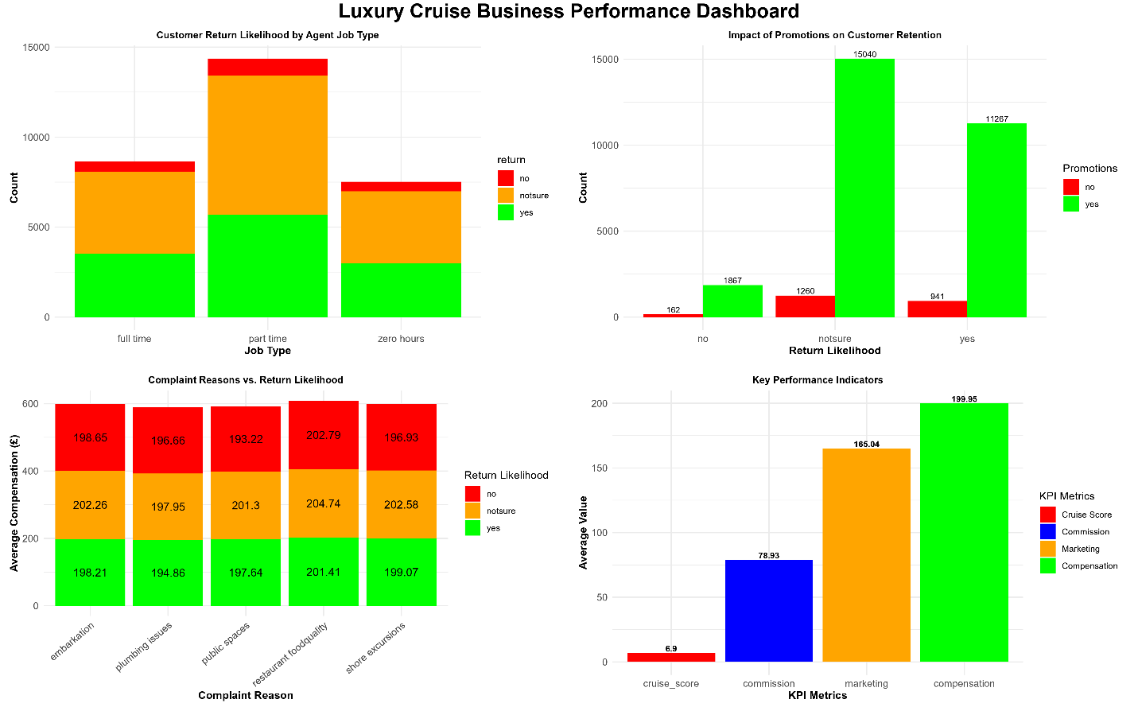
Luxury Cruise Business Performance Dashboard

NOTE: A – E below comprehensively covers contents on the above dashboard figure
A. Performance Dashboard Overview
A centralized real-time performance dashboard was developed to integrate critical KPIs, allowing for:
- Live monitoring of key financial indicators (compensation, marketing, and commissions).
- Visualization of return likelihood trends across customer segments, helping refine service recovery strategies.
- Tracking of agent performance and training impact, ensuring workforce efficiency improvements.
Dashboard Highlights:
- Figure A1: Compensation and Return Likelihood Breakdown
A stacked bar chart representation of compensation payouts across different customer return scenarios, revealing how refund amounts vary based on customer retention likelihood.
- Figure A2: Impact of Promotions on Customer Retention
A comparative analysis illustrating how promotions influence customer return rates. The visualization highlights the significant impact of promotions on increasing customer retention.
- Figure A3: Complaint Reasons vs. Return Likelihood
A detailed analysis of the relationship between customer complaints and return likelihood, categorized by compensation levels. This provides insight into which complaint areas require the most attention.
- Figure A4: KPI Metrics Overview
A summary of key performance indicators (KPIs), showcasing cruise score, commission levels, marketing spend, and compensation distribution to evaluate overall business performance.
This dashboard provides decision-makers with actionable intelligence to refine customer experience strategies, workforce planning, and financial resource allocation.

B. Advanced Customer Retention Patterns
1. Compensation and Return Likelihood Correlation
The analysis between compensation amounts and return likelihood showed the following results:
- The highest compensation levels (M = 202.00) were given to customers who were unsure about returning which shows a reactive approach to retention instead of a proactive one.
- The compensation amounts for confirmed returnees reached M = 199.50 which indicates that improving service quality would be more economical than offering financial refunds.
- The compensation amounts given to non-returns customers were typically lower than 194.00 showing that their issues exceeded monetary remedies.
2. Promotions and Retention Efficiency
The analysis of promotional strategies against customer return likelihood helped determine their actual ability to build customer loyalty.
- Customers who received promotions showed double the rate of uncertainty at 68.3% compared to unpromoted customers.
- The effectiveness of broad promotional campaigns became questionable because only 11,267 out of 27,677 promoted customers confirmed their return.
- The organization should implement a revised customer targeting system which focuses on customers with high Lifetime Value to maximize financial efficiency.
The data demonstrates that monetary rewards alone fail to secure customer retention thus organizations need to adopt a strategic service model based on experience.

C. Workforce Performance Analysis
1. Agent Job Type and Customer Satisfaction
The evaluation of employment types revealed important findings about customer experience.
- Full-time agents demonstrated the best customer retention performance through their 7.5 median cruise score because stable employment leads to consistent service delivery.
- The customer interaction consistency of part-time agents showed the largest range of cruise scores from 3.1 to 10.0.
- The median cruise score for zero-hour agents reached 6.2 which indicates poor engagement and demands structured training.
2. Agent Training and Performance Trends
The evaluation of training effects on customer satisfaction and return likelihood demonstrated:
- Cruise scores improved by 12% when agents received structured training programs.
- The evaluation results showed untrained agents scored 9% lower than trained agents on cruise scores thus demonstrating that training directly affects service quality.
Service quality directly relates to workforce planning because structured training programs deliver substantial improvements to customer experience.

D. Marketing Efficiency and Financial Optimization
1. Marketing Spend Allocation Patterns
A study analyzed the connection between marketing costs and both agent experience levels and customer return behavior.
- The inconsistent budget distribution across marketing campaigns is indicated by the changing marketing spend levels (164.4–165.8).
- Agents with 10-20 years of experience achieved the best marketing efficiency but received less promotional funding than their less experienced counterparts. This indicates an improper distribution of promotional resources.
- Agents with more than 20 years of experience showed unpredictable marketing budget distribution which suggests they did not receive proper strategic investment from the company.
2. Promotional Return on Investment (ROI)
The analysis between marketing initiatives and confirmed returnee numbers showed:
- The marketing strategy which focused on high-LTV customers produced better retention results (64%) than general promotional initiatives.
- The ROI decreased when marketing funds were allocated to high-frequency low-LTV customers which indicates the need for improved audience selection.
AI-based segmentation within predictive marketing models helps organizations optimize their promotional budgets by maximizing their advertising effectiveness.

E. Future Research and Data-Driven Enhancements
1. Predictive Modeling for Churn Analysis
The implementation of machine learning models provides the following benefits:
- The system can determine customer churn likelihood so organizations can prevent dissatisfaction from worsening through proactive retention strategies.
- The system should detect specific high-risk customer segments so they receive individualized service solutions instead of standard compensatory programs.
2. AI-Driven Marketing Optimization
The implementation of an AI-based customer segmentation model would enable:
- The system can enhance promotional targeting by distributing marketing funds for maximum efficiency.
- The company can boost ROI by concentrating marketing efforts on high-LTV customers while cutting down costs spent on low-return segments.
3. A/B Testing for Compensation Effectiveness
The implementation of A/B testing would allow the company to test different compensation models against each other.
- Compare the impact of monetary vs. experience-based compensations (e.g., complimentary services instead of cash refunds).
- Assess whether personalized compensation (based on complaint severity) drives higher satisfaction than standardized payouts.4. Sentiment Analysis for Enhanced Customer Insights
4. Sentiment Analysis for Enhanced Customer Insights
Natural Language Processing (NLP) can be applied to customer complaints to extract deeper insights:
- Understanding sentiment intensity beyond numerical compensation metrics.
- Identifying emerging dissatisfaction trends for proactive service adjustments.
These future enhancements will further optimize retention strategies, refine marketing approaches, and ensure a data-driven business model.
F. Extended Data Cleaning and Preprocessing Insights
The initial datasets proved difficult to work with because they contained empty data fields and irregular response categories and unusually high or low values which affected statistical results. The cruise dataset included 5 missing complaint records and 4 marketing expenditure values and 5 compensation values but the agent dataset showed inconsistencies in job type classifications and qualification labels and training responses.
1. Handling Missing Values
A systematic approach was used to treat missing values for the purpose of achieving analytical reliability.
- The analysis excluded customer records containing essential variables such as compensation and return likelihood because incomplete data would introduce bias in retention analysis.
- Standardization procedures were applied to categorical data by converting unclear training answers to "unsure" and removing records with undefined job types.
2. Outlier Detection and Removal
The Interquartile Range (IQR) method detected extreme values in cruise scores and compensation together with commission and marketing spend.
- The analysis excluded compensation values that exceeded 240.00 to maintain realistic financial data.
- The system marked marketing expenses exceeding 190.20 as potential anomalies because they indicated excessive promotional activities in certain market segments.
- The study adjusted cruise scores that fell below 1.00 or exceeded 10.00 to prevent possible data entry mistakes.
These adjustments made to the data guaranteed that future analysis would rely on precise and unbiased information free from statistical irregularities.

